[YOUR ENERGY COMMUNITY]

SHAPING THE ENERGY FUTURE OF [NEIGHBOURHOOD]
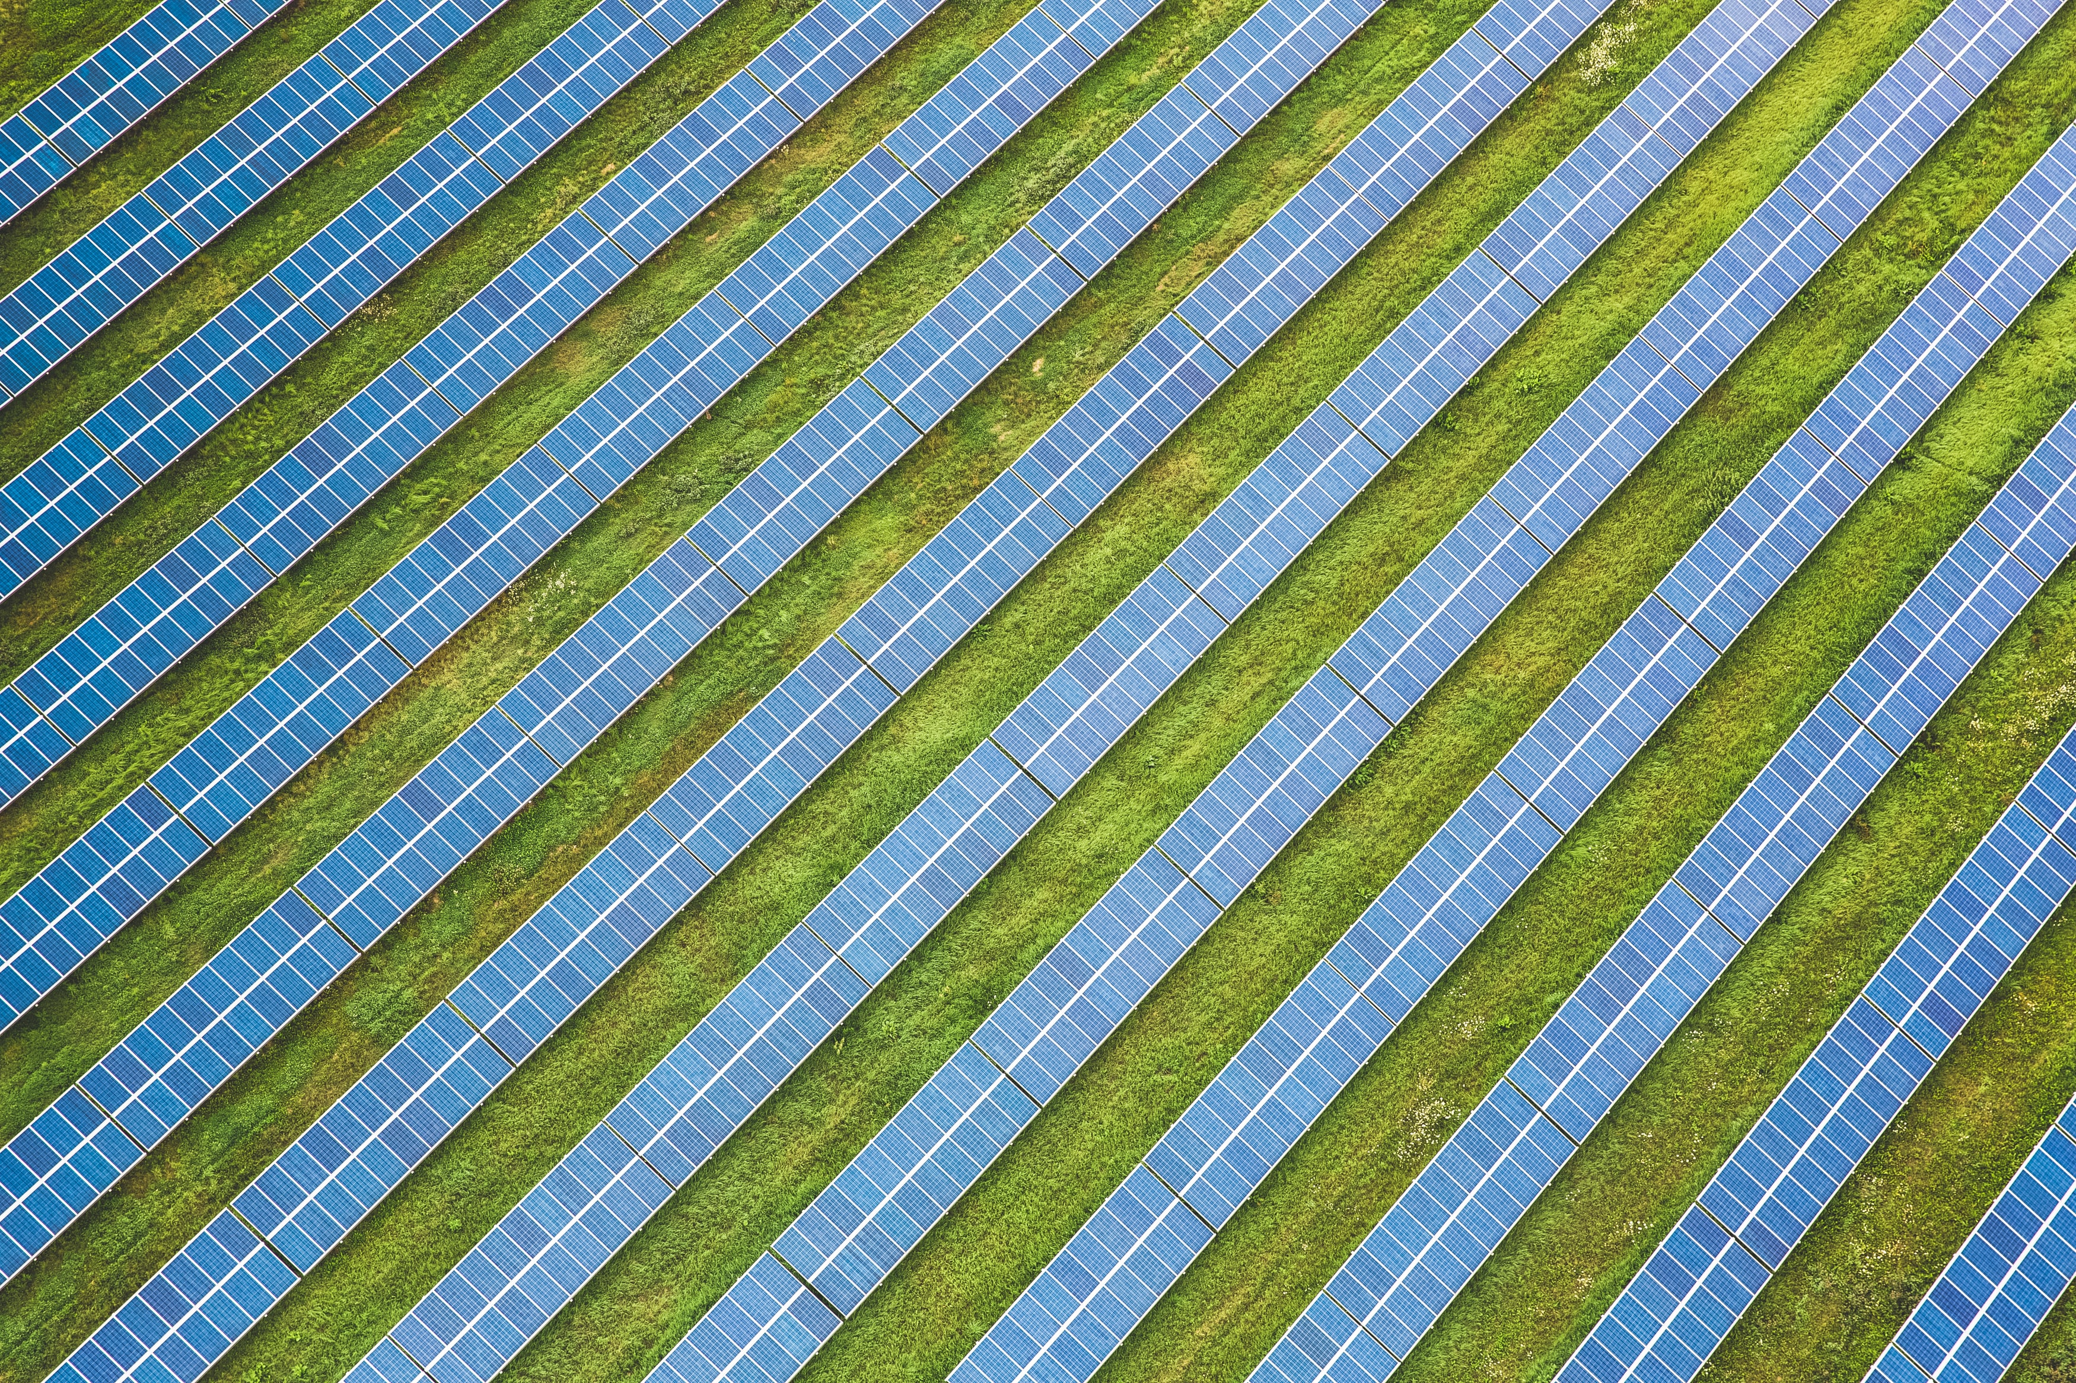

THE [YOUR ENERGY COMMUNITY]

Climate friendly energy locally produced in [Neighbourhood]

[Describe your energy community here:
- Mission and vision statement
- Where do you stand now?
- What is your plan for the next year?
- How does your energy community work?
- …]

Key facts [Summarise the most important key facts & numbers here]
- Location:
- Used energy generation technologies: [e.g. PV, wind, hydro, biogas]
- Number of members:
- Financing model: [e.g. cooperative, …]
- Regional scope: [e.g. national, regional, local]
- Activities in the energy community:

MILESTONES/ROADMAP

Shaping the future of [neighbourhood]

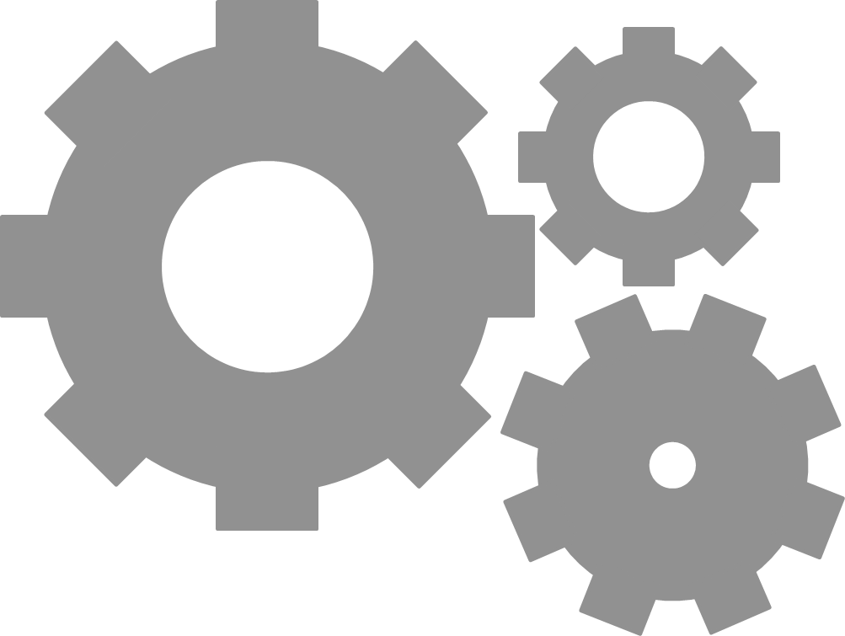
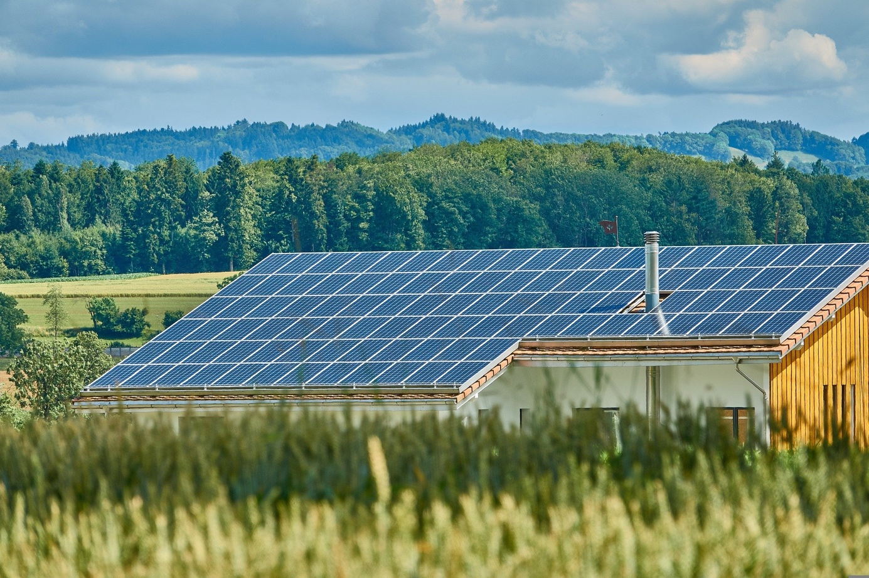
Q1 2023
National versions
published
SHAREs Gateway
One European and six national events organised
SHAREs energy community events
Q3 2024
Blueprint and national versions finalized
SHAREs Gateway
Q1 2024
First version of blueprint finalized
SHAREs Gateway
Pilot + Pioneer
kick-off
Q1 2022
Project start
The first solar plant of our energy community was built in 2022.
Milestones: [Describe important milestones you have already achieved and want to achieve in the future. Insert photos to highlight key events, replace the one above.]
Roadmap: [If you are just starting out tell the reader what your plans and foreseen timeframe is.]
1
Project start
Qx 20xx
Qx 20xx
Qx 20xx
Qx 20xx
Qx 20xx
Qx 20xx

BENEFITS

A win-win-situation for everyone

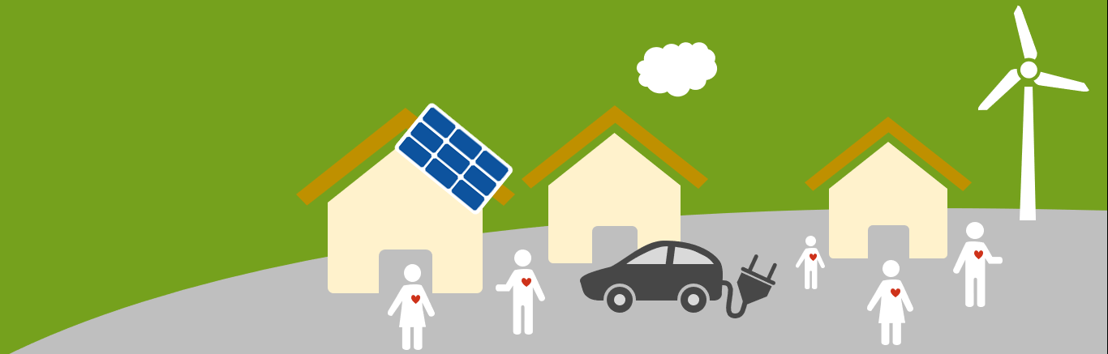

[Describe the advantages of being in an energy community for your target audience.]

It's not complicated and it costs little time to participate.
We will take care of administrative tasks of the energy community and guide you through all necessary steps. However, if you have specific skills or knowledge that you would like to contribute, then this is the perfect time and place to do so.

Taking an active part in an energy community/collective action means that …

… you make your region more independent of fossil fuel imports (you create regional value)
… you become more independent of energy price fluctuations
… you shape the (energy) future of your children and grandchildren
… you get actively involved in your community

[… find out more key messages how to motivate potential members to take part in your actions.]

HOW TO PARTICIPATE

Everyone can be part of the change

[Describe different ways people can join your energy community and how it works:]

1. Consume locally produced energy.
- To do so, you pay a membership fee, and simply rely on your neighbour instead of your current energy provider.
- How? ...

2. Produce climate friendly energy yourself.
- If you already own an energy plant, e.g. photovoltaic panels, you can support your neighbours with the energy you don‘t need for yourself and make some extra money in the meantime!
- How? …

3. Invest in our energy community.
- You‘re looking for a good investment with a clear conscience? Investing in an energy community guarantees a sustainable and steady return on investment.
- How? …

WHO WE ARE

From our community, for our community

[Describe your project team.
- Who is part of the founding group of your energy community?
- How did you end up founding an energy community? What was your personal motivation?
- …]

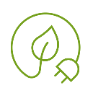

Contact Details:

NAME
Address
Telephone
E-Mail
Website
Social media handles
This work © 2022 by Austrian Energy Agency is licensed under CC BY-NC-SA 4.0. To view a copy of this license, visit http://creativecommons.org/licenses/by-nc-sa/4.0/

