Text module for a short newspaper article
Number of characters including spaces: 749
Number of characters excluding spaces: 635

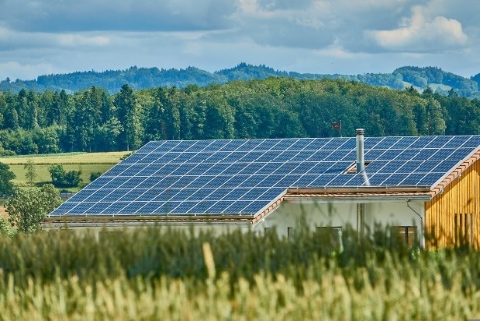
ExampleTown is setting up its first energy community
[Your name] | drafted on [Date]
With the set-up of a renewable energy community, the municipality ExampleTown is once again a pioneer for clean and sustainable energy. The municipality, fire brigade and 25 households are ready to join a local energy community in Exampletown. Its set-up is very beneficial: members can gain independence from the energy market, save money and strengthen the town’s long-term economy.
ExamplePhoto 1: First PV-plant of Exampletown
How you can join? Check out ExampleCommunity’s website Energy4Exampletown.at and facebook page (@ExampleCommunity) for specific requirements and more information. Let us know you are interested in joining and we will keep you posted on the next steps! example@email.com, +43 680 1234 567 89

