Text module for a newspaper article (medium length)
Number of characters including spaces: 2,654
Number of characters excluding spaces: 2,248

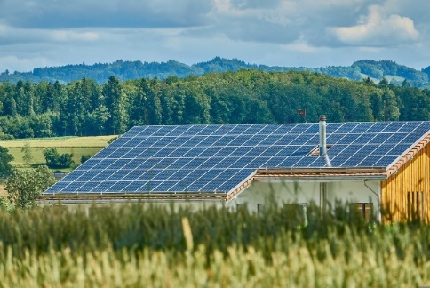
ExampleTown is setting up its first energy community
[Your name] | drafted on [Date]
With the set-up of a renewable energy community, the municipality ExampleTown is once again a pioneer for clean and sustainable energy. The municipality, fire brigade and 25 households are ready to join a local energy community in Exampletown. Its set-up is very beneficial: members can gain independence from the energy market and strengthen the town’s long-term economy.
Local production and consumption of green energy
ExamplePhoto 1: First PV-plant of Exampletown
Energy communities offer local solutions to the global energy crisis: local production – local consumption. Green energy will be shared within the community. In ExampleTown a group will join forces and found an energy community on March 3rd, 2023: Sunshine kindergarten (15 kWp), Sunrise highschool (20 kWp), the Getwell hospital (50 kWp), the fire brigade and 25 households will join. Participants can take part as prosumers (producers & consumers) or solely as consumers. The principle of how an energy community works is quite simple: All members can exchange their locally produced renewable energy. For example, households will be able to use the energy from the school’s PV-panels during the summer break.
Benefits: Lower fees and taxes as well as local value creation
The pricing system is set to cover the installation and maintenance costs for the renewable generation plants of the energy community. The energy community benefits from lower grid fees and tax concessions. This means the energy price is stable compared to the market and, for the most part, will be cheaper than from a regular, profit-oriented energy supplier. [See key messages]
The people engaged in the project
Describe the people behind the project to reduce inhibitions to contact them. If a picture is available, please add it. It’s always nice to see a friendly face and not only quotes.
Angel Allm is the founder of ExampleCommunity. Her expertise in energy law laid the foundation for her activities as the driver of collective actions.
Create some personal impressions. If a picture is available, please add it. It’s always nice to see a friendly face and not only quotes.
Sophie Surname is one of the first citizens of ExampleTown to become active in the energy project and shares her story: “We are very excited to be part of ExampleCommunity. We started out as a local energy group, helping each other out regarding the thermal insulation of our homes, sharing energy saving tips and small-scale carsharing. Now we are taking the next step towards energy independency.”
Tell people how they can join or support your project, e.g. with a fact box:
How you can join?
It’s simple, we will take care of all formalities, including billing. Check out ExampleCommunity’s website Energy4Exampletown.at and facebook page (@ExampleCommunity) for specific requirements and more information. Let us know you are interested in joining and we will keep you posted on the next steps!
Remember to name your contact details:
Contact information
ExampleCommunity
@ExampleCommunity
example@email.com
+43 680 1234 567 89

