Text module for a long newspaper article
Number of characters including spaces: 4,321
Number of characters excluding spaces: 3,665

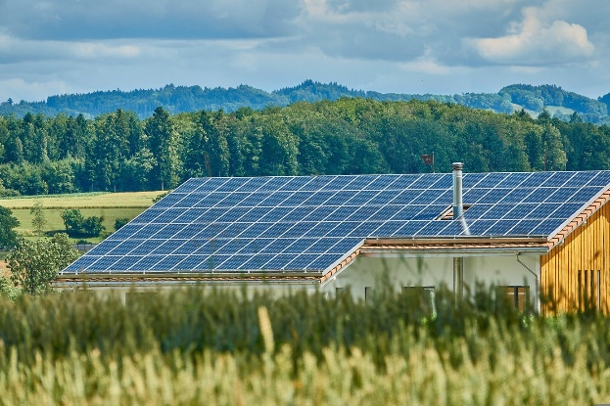
ExampleTown is setting up its first energy community
[Your name] | drafted on [Date]
With the set-up of a renewable energy community, the municipality ExampleTown is once again a pioneer for clean and sustainable energy.
The municipality, fire brigade and 25 households are ready to join a local energy community in Exampletown. Its set-up is very beneficial: members can gain independence from the energy market and strengthen the town’s long-term economy. With channelled efforts and by applying joint knowledge, ExampleCommunity aims to help its members reduce their energy costs. Here is how.
ExamplePhoto 1: First PV-plant of Exampletown

Local production and consumption of green energy
Energy communities offer local solutions to the global energy crisis: local production – local consumption. Green energy will be shared within the community. In ExampleTown a group of different participants will join forces and found an energy community on March 3rd, 2023: On the municipality’s side, Sunshine kindergarten (15 kWp), Sunrise highschool (20 kWp) and the Getwell hospital (50 kWp) as well as the fire brigade will join. On the residential side, 25 households are interested in participating. Participants can take part as prosumers (producers & consumers) or solely as consumers. The principle of how an energy community works is quite simple: All members can exchange their locally produced renewable energy. For example, households will be able to use the energy from the school’s PV-panels during the summer break and in morning and evening hours. Details of the distribution and settlement will be agreed on amongst the participants. The conventional supplier provides the residual amount of electricity needed.
Benefits: Lower fees and taxes as well as local value creation
The pricing system is set to cover the installation and maintenance costs for the renewable generation plants of the energy community. The energy community benefits from lower grid fees and tax concessions. This means the energy price is stable compared to the market and, for the most part, will be cheaper than from a regular, profit-oriented energy supplier. With each additional local plant installed, the community becomes increasingly independent. By joining, you can create jobs and help local businesses grow, leading to local value creation. [See key messages]

Through the energy community, members will be able to exchange their locally produced renewable energy. In a more advanced stage, battery storage units could be installed as well. This would make ExampleTown more resilient against possible blackouts.
Create some personal impressions. If a picture is available, please add it. It’s always nice to see a friendly face and not only quotes.
Reactions from participants are positive
Sophie Surname is one of the first citizens of ExampleTown to become active in the energy project and shares her story: “We are very excited to be part of ExampleCommunity. We started out as a local energy group, helping each other out regarding the thermal insulation of our homes, sharing energy saving tips and small-scale carsharing. Now we are taking the next step towards energy independency.” Alex Surname, another member of the newly founded energy community, continues: “Now, the municipality has engaged with us through citizen-financed PV-plant installations and is helping us develop the town’s energy transition. What really surprised me was how easy it is to join and benefit from the advantages of such a community.”
Tell people how they can join or support your project e.g. in a fact box:
How you can join?
Participating in an energy community is simple. We will take care of all formalities, including billing. You can take part by selling the electricity produced with your own PV, or just by buying clean energy from your neighbour. Check out ExampleCommunity’s website Energy4Exampletown.at and facebook page (@ExampleCommunity) for specific requirements and more information. You can contact us directly and let us know you are interested in joining. We will keep you posted on the next steps and invite you to our next meeting in ExampleTown Hall!

Describe the people behind the project to reduce inhibitions to contact them. If a picture is available, please add it. It’s always nice to see a friendly face and not only quotes.
The person behind ExampleCommunity
Angel Allm is an engaged citizen of ExampleTown who has been driving collective actions for 7 years now. Her expertise in energy law laid the foundation for her volunteer activities. The RED II transposition in [Country] was finalised just in time for her to plan her next energy project, ExampleCommunity.
Remember to name your contact details:

Contact information
ExampleCommunity
@ExampleCommunity
example@email.com
+43 680 1234 567 89

